**Cryptocurrency Price Prediction: Bitcoin**

Data Science Applications

EBC 7100



**Masters in Electronic Business Technologies**

|  |  |
| --- | --- |
| **Submitted by: -**  Ali Debek 300102000  Monika Yadav 300069727  Nikhil Widhani 300051475  Simarpal Singh 300076876 | **Submitted to: -**  Prof. Arya Rahgozar |

# **Project Objective**

The problem we are addressing in this project is the prediction of the Bitcoin price based on the historical trends we obtained from the Yahoo Finance site, by producing a prediction algorithm, analyze the results obtained and communicate the insights. For this purpose, we

used a Bitcoin dataset, ranges from the *16th of March 2017* until the 5th *of April 2019*, and we applied Long Short-Term Memory machine-learning algorithm (LSTM) to predict the daily price change of this cryptocurrency.

# **Cryptocurrency Background Review**

Cryptocurrency is one of the emerging Internets technology uses as currency over the traditional monetary system. The term cryptocurrency means the digital currency or the virtual currency, that works as a mode of exchange or transfer of assets digitally. The market of cryptocurrency has evolved at an exponential speed in a short span of time. The first cryptocurrency was introduced in 2009 named as Bitcoin by Satoshi Nakamoto. Later on, thousands of cryptocurrencies start running in the market. Unlike centralized banking system and electronic money, cryptocurrencies follow the decentralized system, which means it supports blockchain transactional databases.

In centralized banking system, there is the hierarchy of network and government that controls the overall currency system, However, Cryptocurrency Bitcoin does not need a central bank or institution to emit and control it. Its transactions are evaluated and stored in the network itself, in a peer-to-peer format, using cryptography techniques to validate transactions

A sample blockchain is shown in Fig.1.

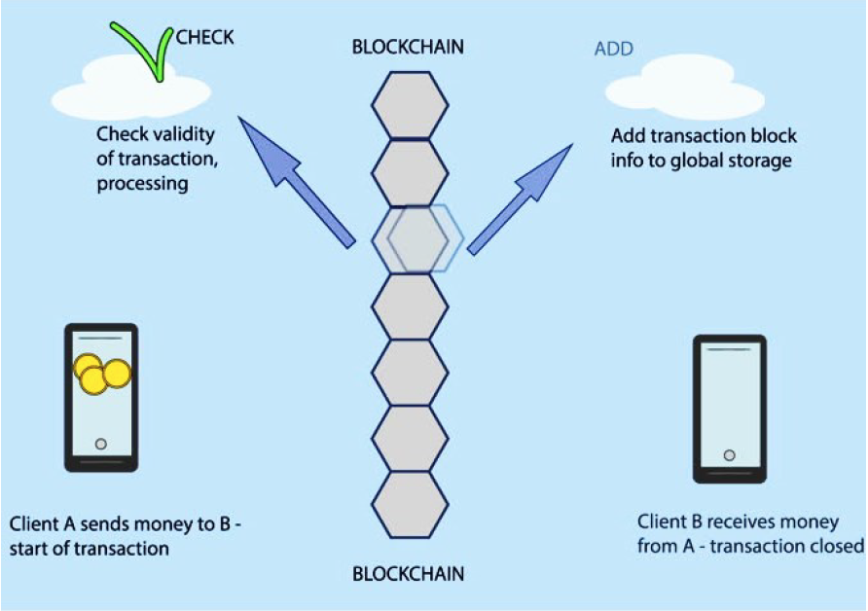

Fig.1. Cryptocurrency workflow using blockchain mechanism

Bitcoin is defined as a chain of digital signatures, where each owner transfers the coins to the other using a digital signature, which contain a hash of the previous transactions and the public key of the next owner, adding this information to the end of the coin. Bitcoin network is composed by a high number of computers connected through the Internet. In order to avoid the need of a trusted party to validate transactions, it was implemented a proof-of-work mechanism where the nodes perform complex mathematical procedures to verify the correctness and truthfulness of the transactions. When the proof-of-work is finished, one block is added to the chain (Blockchain). The block cannot be changed without re-doing the work. This represents a similar scheme to the gold miners.

Bitcoin is attractive for investors and traders, as it is traded on over 40 exchanges worldwide accepting over 30 different currencies, with a market capitalization of 9 billion USD according to https://www.blockchain.info/ for 2018 and sees over 250,000 transactions taking place per day. However, the challenge in predicting the Bitcoin exchange rate is its high volatility. Therefore, the prediction of its behavior is of great importance for financial markets.

# **Long Short-Term Memory Network Overview**

The Long Short-Term Memory networks – known as “LSTMs” – are a special kind of Recurrent Neural Network (RNN) capable of learning long-term dependencies. They were introduced by Hochreiter & Schmidhuber (1997). All RNNs have the form of a chain of repeating modules of neural network (A as illustrated below). In standard RNNs, this repeating module will have a very simple structure, such as a single tanh layer.

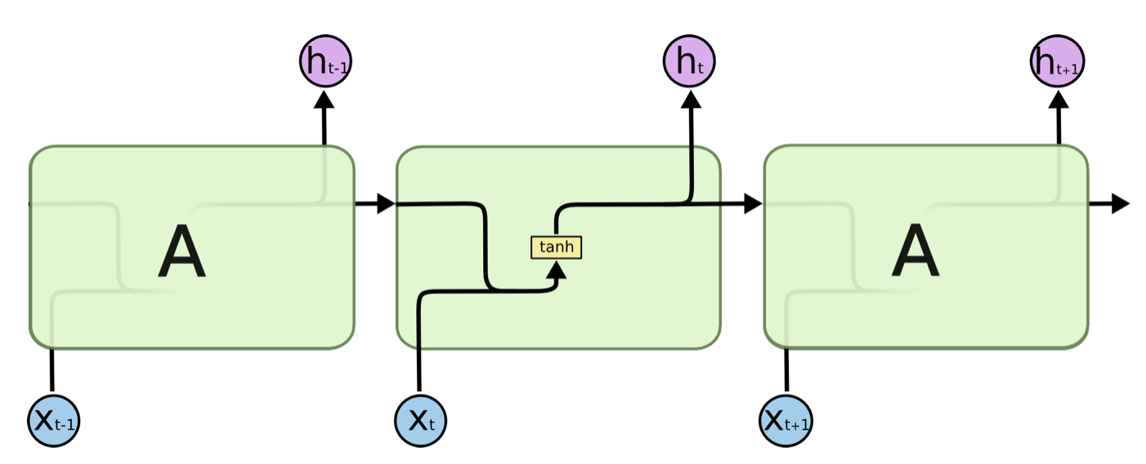

**Standard RNN contains a single layer**

LSTMs also have this chain like structure, but the repeating module has a different structure. Instead of having a single neural network layer, there are four, interacting in a very special way.

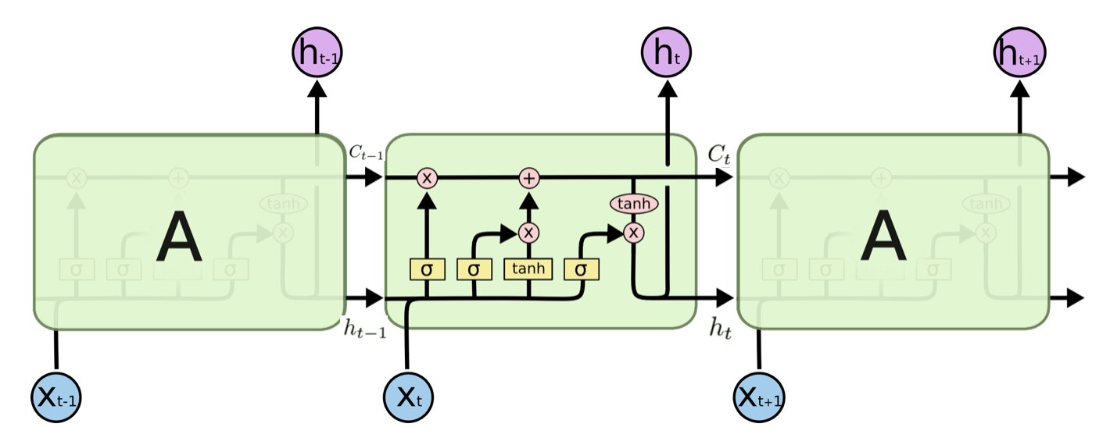

**LSTM contains four interacting layers**

In the above diagram, each line carries an entire vector, from the output of one node to the inputs of others. The pink circles represent pointwise operations, like vector addition, while the yellow boxes are learned neural network layers. Lines merging denote concatenation, while a line forking denotes its content being copied and the copies going to different locations.

The basic LSTM cell, **X** is the input to the cell, **h** the short-term memory and **C** the long-term memory. The subscript **t** refers to the time

At each time step, **t**, the LSTM cell takes 3 inputs: the input **xt** the short-term memory **ht-1**and the long-term memory **Ct-1** and outputs the long-term memory **Ct**at and short-term memory **ht**

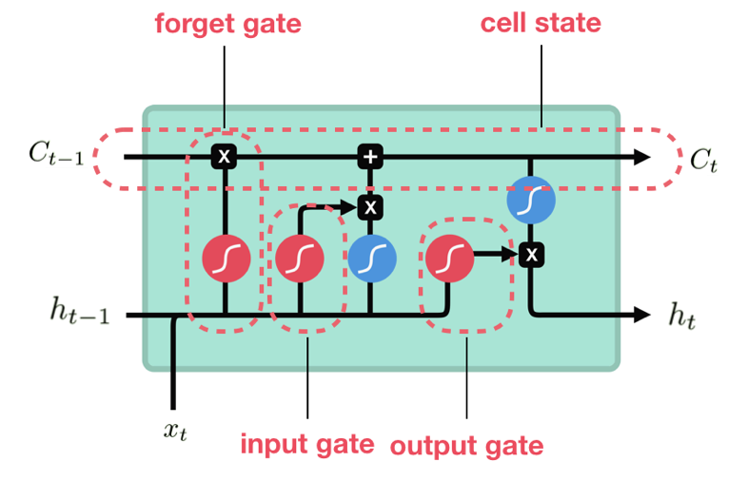

An LSTM has three of these gates, to protect and control the cell state

- The Forget Gate ***ft*** controls the amount of short-term memory, **h**, to be remembered for further flow in the present time step. Mathematically we can represent Forget Gate ***ft***as:

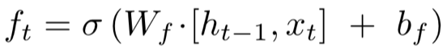

Where **σ** represents the sigmoid activation function, **Wf** is the weight controlling the influence of input **Xt**, short-term memory **ht-1**, and **bf**the bias of the forget gate.

- The Input Gate ***it*** controls the amount of input and working memory influencing the output of the cell. We can express it as follows:

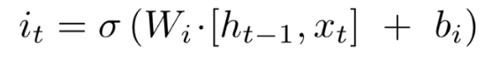

The LSTM cell also computes the candidate hidden state  , which along with the input and forget gate, is used to compute the amount of long-term memory **Ct**:

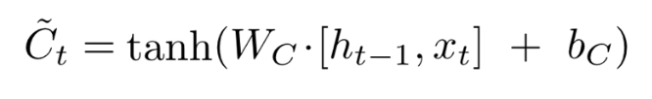

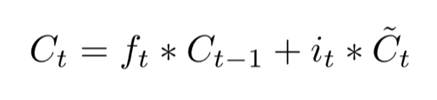

- The Output Gate ***Ot*** controls the amount of information that's used for updating the short-term memory, and given by the following:

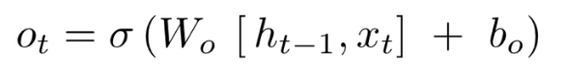

The new value of the short-term memory is then computed as the following:

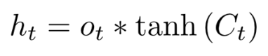

# **CRISP Methodology**

The methodology we follow in our project is the CRISP-DM methodology that stands for Cross-Industry Standard Process for Data Mining that comprises six stages cycle (Fig. 2)

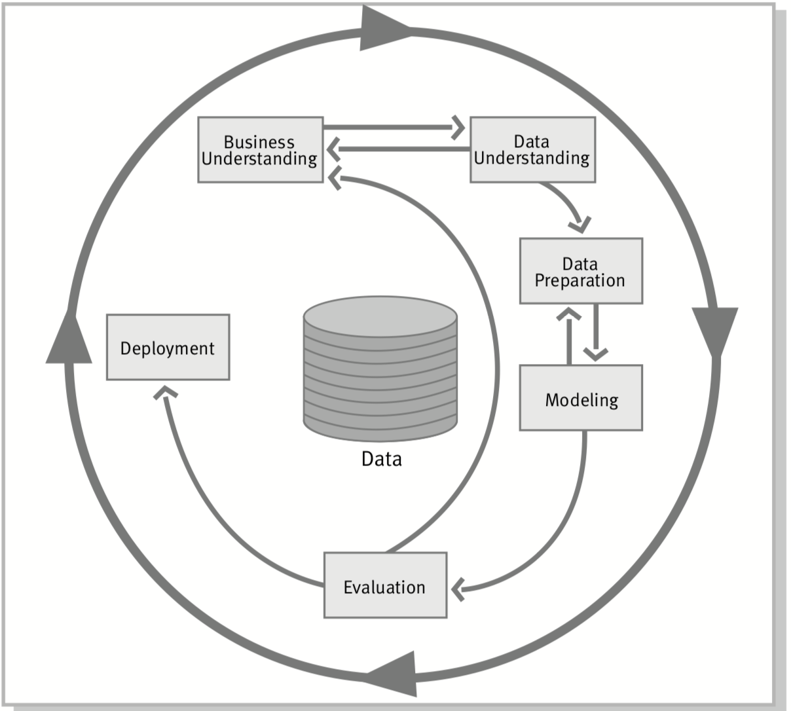

Fig.2. Phases of the CRISP-DM reference model

(1) Business understanding - that focuses on understanding the project objectives and requirements from a business perspective, then converting this knowledge into a data mining problem definition;

(2) Data understanding - that starts with an initial data collection and proceeds with activities in order to get familiar with the data, to identify data quality problems;

(3) Data preparation - that covers all activities to construct the final dataset from the initial raw data;

(4) Modeling - is the phase where various modeling techniques are selected and applied, and their parameters are calibrated to optimal values;

(5) Evaluation - is the phase where the steps and the results of the model are reviewed and evaluated to assess the performance of that model;

(6) Deployment phase - that represents the creation and deployment of the model in practice

In our project, the steps picked from CRISP methodology can be summarized as follow:

# **Data**

## **Data Selection**

We got the dataset of Bitcoin from the Yahoo Finance website for the period between 16th of March 2017 and 16th of March 2019. The dataset contains the daily price in US dollar. The daily price is computed as the volume weighted average of all prices reported at each market.

In our given dataset, the independent variable is the average closing price of Bitcoin in USD.

The dependent variables are the opening price, daily high and daily low and mining difficulty

|  |  |
| --- | --- |
| **Parameter** | **Description** |
| Date | Date to which data is picked |
| Open | Open price of the day |
| High | High price of the day |
| Low | Low price of the day |
| Close | Closing price of the day |

# **Set-up Python Ecosystem**

We started the setup of Python the ecosystem by installing and importing the packages/libraries of: numpy, pandas, matplotlib, scikit-learn, and Kerras:

1. **import** numpy as np
2. **import** pandas as pd
3. **from** matplotlib **import** pyplot as plt
4. **from** sklearn.metrics **import** confusion_matrix
5. **from** sklearn.utils.multiclass **import** unique_labels
6. **from** keras.models **import** Sequential
7. **from** keras.layers **import** Activation, Dense
8. **from** keras.layers **import** LSTM
9. **from** keras.layers **import** Dropout

# **Getting Data Yahoo Finance**

We get the data from Yahoo Finance in .CSV format and we load them directly into a Pandas DataFrame.

1. **import** pandas as pd
2. read_dataFrame = pd.read_csv('BTC-USD_latest.csv')
3. data = read_dataFrame.iloc[:, 4:5]

## **Data Preparation & Partition**

We apply the following steps

1- Normalizing our data using *MinMaxScalar*. MinMaxScalar scales all the data to be in the region of 0 and 1.

1. **from** sklearn.preprocessing **import** MinMaxScaler
2. min_max_scaler = MinMaxScaler()
3. data_scaler = min_max_scaler.fit_transform(data)

2- Splitting the full series into windows, for this purpose we choose the temporal length of our window size to 60 days.

3- Defining Parameters:

the parameters we defined in LSTM network for time series predictions are the following:

**Temporal length Window**: In terms of temporal length, the LSTM is considerably better at learning long term dependencies. As a result, the most effective window in our dataset was for 60 days.

**Number of Hidden Layers**: For a time series tasks, two layers is enough to find nonlinear relationships among the data, we used in our case 2 layers, and we set the number of nodes in the first and second layers to be **20 nodes** and **40 nodes** respectively

**Batch**: The batch size is a hyperparameter that defines the number of samples to work through before updating the internal model parameters. In our case, we set the value to:

* **Batch size =** 25

**Epoch**: The number of epochs is a hyperparameter that defines the number times that the learning algorithm will work through the entire training dataset. it is related to the backpropagation through time (BPTT) that is used to optimize the LSTM model.

In our case, we set the value to:

* **Epoch Size =** 200

## **Dataset Partition**

We partition data into training and test sets. We build our model on the training set and evaluate it on the test set.

**Training Set**: We have taken 60 days as our window size. Each row in X_train is of size 60. We want to train our model in such a way that if we give the first 60 days then it will predict 61st day, so Y_train first row value is 61st day value. Similarly, the second row of X_train starts from 2nd day to 61st day value and Y_train second row is 62nd day value and so on.

**Testing Set:** In a similar way, we have prepared testing sets as shown in line 10 to 14 of below code.

1. X_train = []
2. Y_train = []
3. **for** i **in** range(60, 600):
4. X_train.append(data_scaler[i-60:i, 0])
5. Y_train.append(data_scaler[i])
7. X_train = np.array(X_train)
8. Y_train = np.array(Y_train)
10. X_test = []
11. Y_test = []
12. **for** i **in** range(600, len(data_scaler)):
13. X_test.append(data_scaler[i-60:i, 0])
14. Y_test.append(data_scaler[i])
16. X_test = np.array(X_test)
17. Y_test = np.array(Y_test)
19. X_train = np.reshape(X_train, (len(X_train), 1, X_train.shape[1]))
20. X_test = np.reshape(X_test, (len(X_test), 1, X_test.shape[1]))
22. **print**(X_train.shape)
23. **print**(X_test.shape)
24. **print**(Y_train.shape)
25. **print**(Y_test.shape)

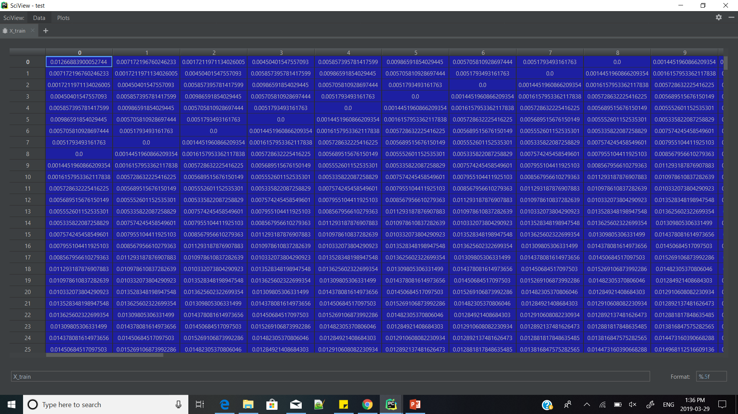

Fig : X_train

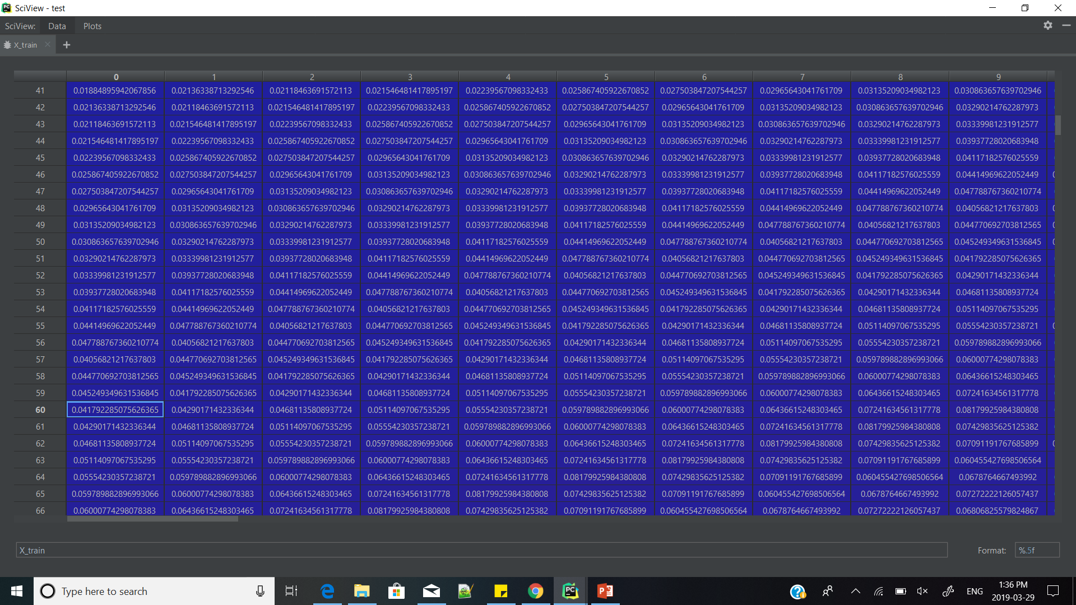

Fig: X_Train 60 row

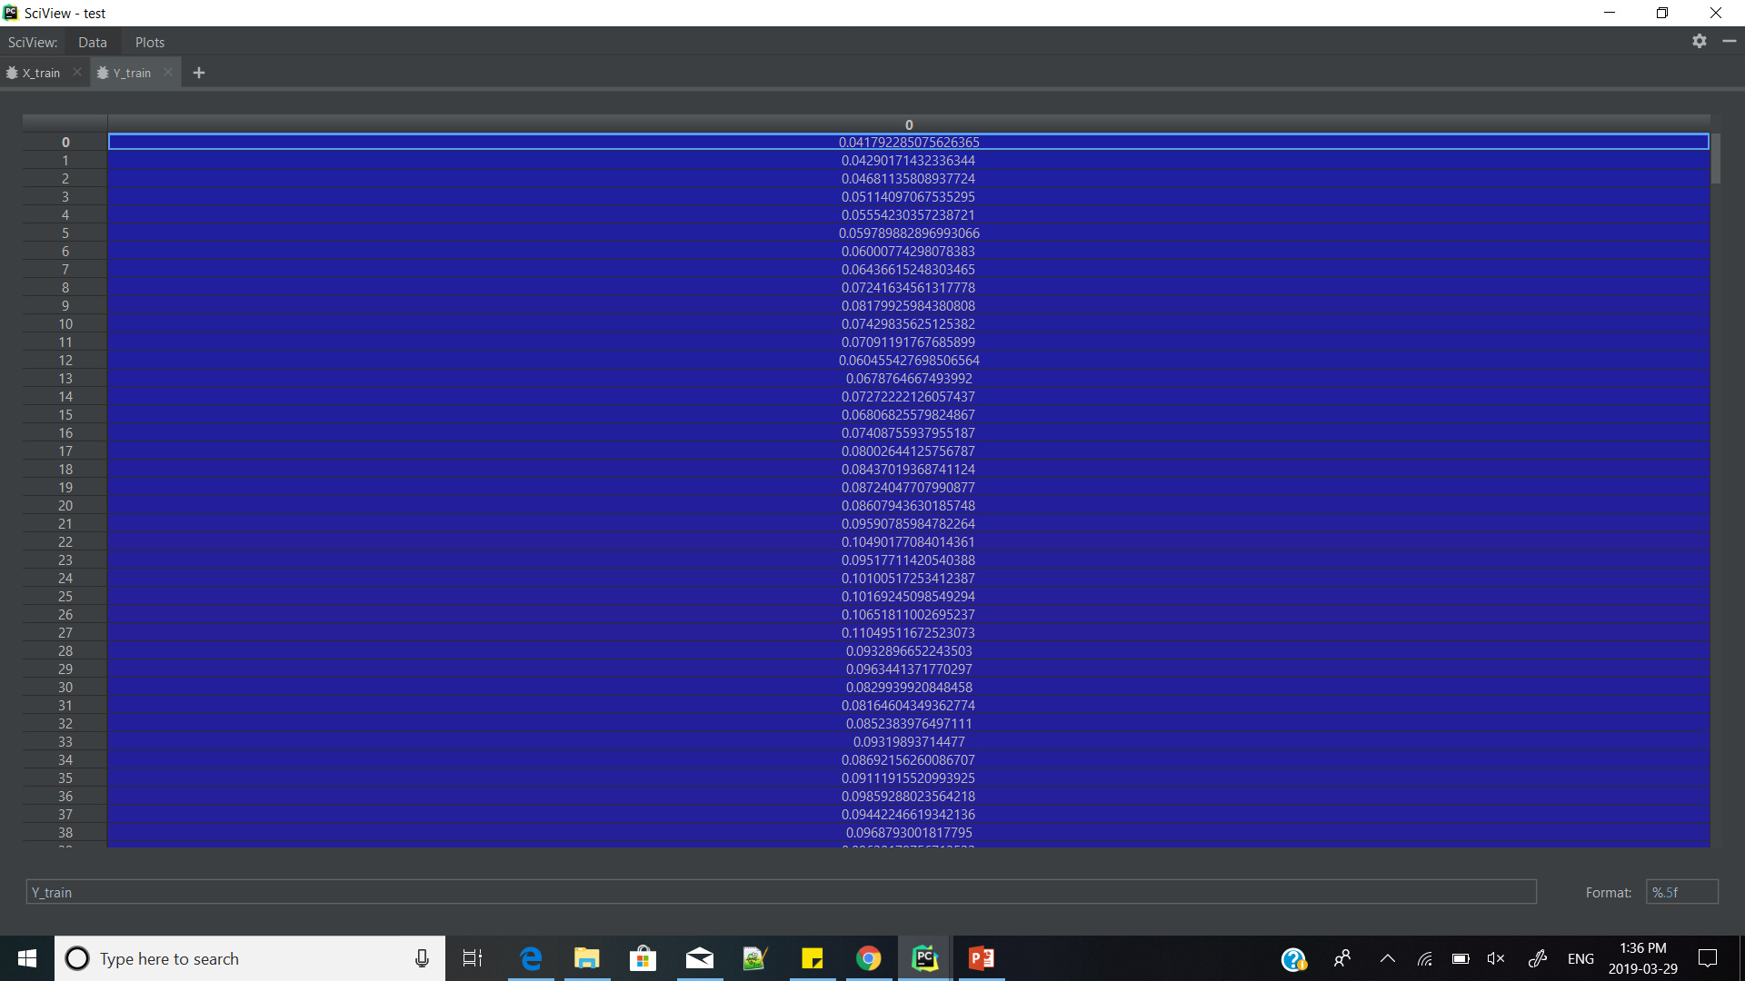

Fig: Y_train

# **Modeling**

## **LSTM Prediction Model**

There are several deep learning models available. For example, feed forward network, but in this we just give input and it does not learn from its past state. RNN solve that problem which learns from its hidden state (previous learned state) however if the input data is a long series of data then while training gradient value keeps on decreasing when we move one layer to another. This gradient value is very important which is used to update the weight of each neuron of the model. To overcome this problem LSTM was developed, which is perfect for a long series of data. Therefore, we have chosen the LSTM model.

1. **from** keras.models **import** Sequential
2. **from** keras.layers **import** Activation, Dense
3. **from** keras.layers **import** LSTM
4. **from** keras.layers **import** Dropout
6. model = Sequential() #Initializing model Sequential
7. model.add(LSTM(20, return_sequences=True,  input_shape=(X_train.shape[1], X_train.shape[2])))
8. model.add(LSTM(40))
9. model.add(Dense(units=1))
10. model.compile(loss='mean_squared_error', optimizer='adam', metrics=['accuracy'])
11. model.summary()
12. history = model.fit(X_train, Y_train, epochs=200, batch_size=24, verbose=2, shuffle="batch", validation_data=(X_test, Y_test))
14. # predicting test data
15. LSTM_prediction = model.predict(X_test)
16. predicted_price = min_max_scaler.inverse_transform(LSTM_prediction)
17. actual_price = min_max_scaler.inverse_transform(Y_test)

We have used keras library, which is a high-level API to build and train deep learning models. It run on top of TensorFlow.

We have built two layers of LSTM model with 20 neurons in first layer and 40 neurons in second layer. Then on line number 13, we are fitting the input data into the model for training. In line number 16 we are predicting output against testing data.

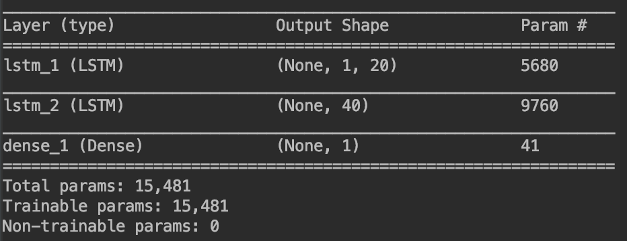

# **Error Analysis**

1. **Confusion Matrix**

A different approach was used to create confusion matrix by taking Root Mean Square Error (RMSE) into account. Difference was calculated between actual price and predicted price which was then compared to RMSE and confusion matrix was plotted by the logic

1. confusion matrix
2. diff = predicted_price - actual_price
3. **from** math **import** sqrt
4. **from** sklearn.metrics **import** mean_squared_error
5. RMSE = sqrt(mean_squared_error(actual_price, predicted_price))
6. accurate_prediction = np.where(diff < RMSE, 0, 1)
7. **print**(np.array(accurate_prediction).size)
8. zero_array = np.full((diff.size, 1), 0, dtype=int)
9. confusion_matrix = confusion_matrix(zero_array, accurate_prediction)
10. **print**(confusion_matrix)

If Diff > RMSE = 0

Else = 1

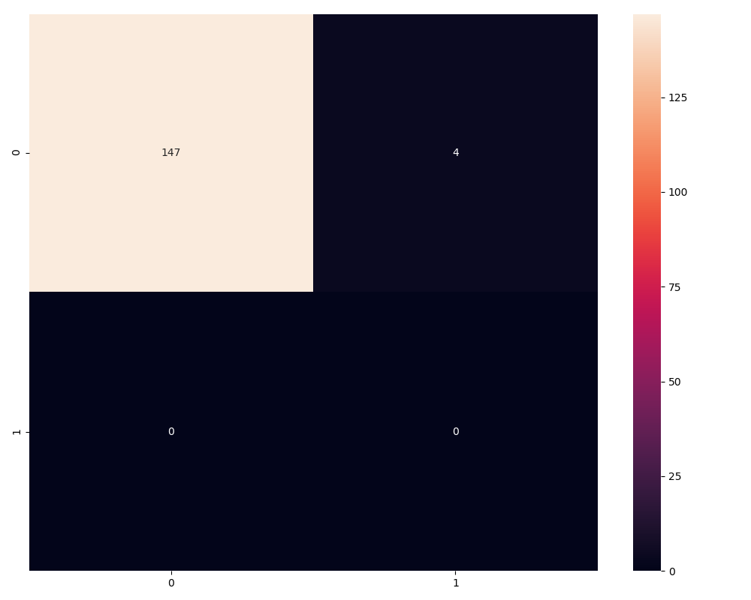

1. **Loss Plot**

Loss Plot is used to check loss of model while training. Loss curve should always be declining as model learns with every iteration. Epoch and batch size were changed in order to reduce loss curve

1. #loss Plot
2. plt.plot(history.history['loss'])
3. plt.title('Loss Plot')
4. plt.legend(['loss'], loc='upper right')
5. plt.show()



1. **Model Train vs Validation Loss**

It is the measure of loss while training and after training. It helps to check underfitting and over fitting in our model. Both the curves should not touch and be very apart from each other. Our model curve is perfect as they both are close to each other which represents our model is not over fitting or under fitting.

1. #Loss Vs Validation Loss
2. **from** matplotlib **import** pyplot
3. pyplot.plot(history.history['val_loss'])
4. pyplot.plot(history.history['loss'])
5. pyplot.title('model train vs validation loss')
6. pyplot.ylabel('loss')
7. pyplot.xlabel('epoch')
8. pyplot.legend(['train', 'validation'], loc='upper right')
9. pyplot.show()



# **Results**

Once all the measures are finalized and model is improved then we then plot results and they are represented by line graph which is depicted below. Red colour represents real price and Blue curve represents predicted price of bitcoin.

1. #Price Prediction vs actual price
2. plt.figure(figsize=(20, 8))
3. plt.plot(predicted_price, color='blue', label='Predicted price of the bitcoin')
4. plt.plot(actual_price, color='red', label='Real price')
5. plt.title('Predicted vs real price of bitcoin')
6. plt.xlabel('Time')
7. plt.ylabel('Price')
8. plt.legend(['Predicted price of the bitcoin', 'Real price'], loc='upper right')
9. plt.show()
10. plt.savefig('plot.png')



1. #Future Prediction + 10 days
2. plt.plot(predicted_price, color='blue', label='Predicted price of the bitcoin + 10 days Future prediction')
3. plt.plot(actual_price, color='red', label='Real price')
4. plt.title('Predicted vs real price of bitcoin')
5. plt.xlabel('Time')
6. plt.ylabel('Price')
7. plt.legend(['Predicted price of the bitcoin', 'Real price'], loc='upper right')
8. plt.show()
9. plt.savefig('plot.png')



# **Conclusion**

Deep learning models like the RNN and LSTM are effective for Bitcoin prediction with the LSTM more capable for recognising longer-term dependencies.

While Deep learning models require a significant amount to data to learn effectively, the limitation we had in our project is that we couldn’t implement the model using a real time streaming data predicting into the future as opposed to learning what has already happened- We think that the ability to predict using streaming data should improve the model.

* LSTM model performs well but we need an additional model or technique with it for predicting highly accurate results (e.g. Sentiment Analysis)
* We observed that Performance of LSTM model differ from computer to computer based on GPU and CPU availability and specifications.
* The Lack of Free Data Sources and Real Time data affects performance of our model.

# **Future Work**

We think our project can be extended and improved by elaborating the scope that can be summarized by the following ideas:

* Using Realtime API for Data Collection
* Creating our own API for Distribution
* Using Sentiment Analysis for improving accuracy of model
* Implementing RNN or ARIMA models with LSTM

## **References**

* S. McNally, J. Roche, and S. Caton, “Predicting the Price of Bitcoin Using Machine Learning,” in Proceedings of the 2018 26th Euromicro International Conference on Parallel, Distributed and Network-based Processing (PDP), pp. 339–343, Cambridge, March 2018.
* RUCHI MITTAL et al.: Automated Cryptocurrencies Prices Prediction using Machine Learning, ICTACT Journal on Soft Computing, July 2018, Volume: 08, Issue: 04
* CRISP-DM 1.0 Step-by-step data mining guide , SPSS , 2000
* https://fianance.yahoo.com
* https://towardsdatascience.com